

**VIETNAM NATIONAL UNIVERSITY HO CHI MINH CITY**

**HO CHI MINH CITY UNIVERSITY OF TECHNOLOGY**

**FACULTY OF COMPUTER SCIENCE AND ENGINEERING**

**🙞∙∙∙☼∙∙∙🙜**



**LAB_1 REPORT**

**CLASS CC01 – GROUP 1**

SUBJECT:

LOGIC DESIGN

**Instructor: Nguyễn Thiên Ân**

|  |  |
| --- | --- |
| **Student** | **ID** |
| Bùi Thái An  Phạm Nguyễn Hải Khánh  Nguyễn Đăng Duy | 2252001  2252333  2252116 |

***2 Exercises***

***2.1 Exercise 1***

***Clock Frequency Divider Police Siren: Design a circuit that generate a 1 Hz output signal using Behavioral Model. This signal is connected to 2 RGB LEDs (1 displays the blue color, 1 display the red color) on Arty-Z7 FPGA Board to make it blink interleave with each other (turn on for 0.5s - turn off for 0.5s). Know that the input clock frequency is 125 MHz. Write test benches to simulate the circuits. Test the circuits on FPGA board using LEDs and RGB LED:***

`timescale 1ns/1ps

module work_space(clk,blue_light,red_light);

input clk;

input clk;

output blue_light,red_light;

reg [30:0]cnt =0;

always @(posedge clk) begin

if (clk ==1) cnt <= cnt + 1;

if (cnt == 9)

cnt <=0 ;

end

assign red_light = (cnt < 5)?1:0;

assign blue_light = (cnt <5 )?0:1;

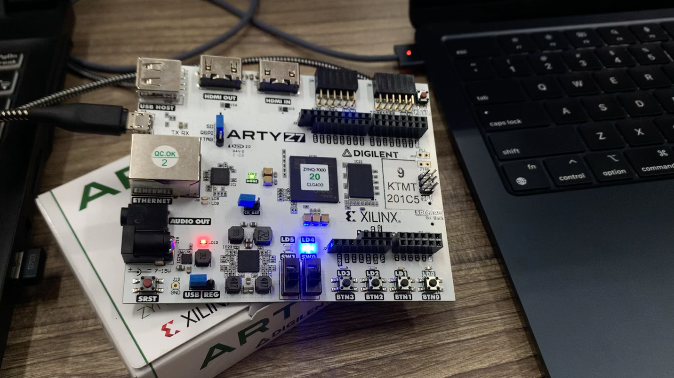endmodule

**TEST BENCH:**

`timescale 1ns / 1ps

module lab3_tb();

reg clk;

wire red_light,blue_light;

initial begin

forever #5 clk = ~clk;

end

initial begin

clk = 0;

end

work_space somthing(clk,blue_light,red_light);

endmodule

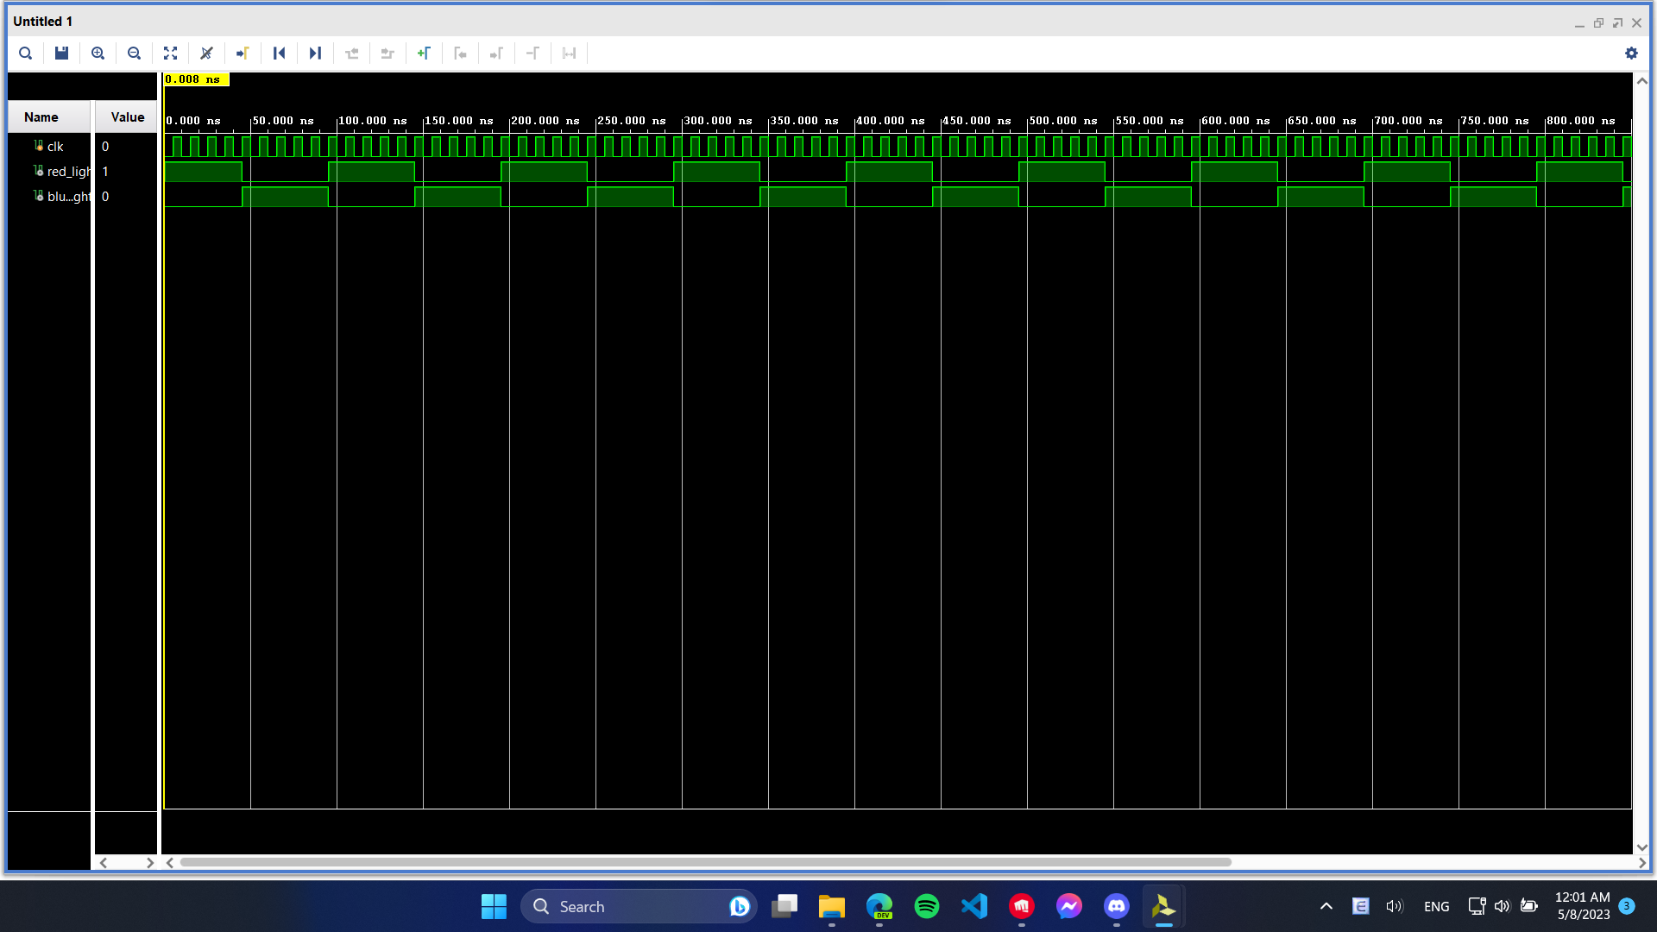

***2.2 Exercise 2***

***a. Edge Detection circuit. a. Design a Rising Edge Detection circuit. This circuit will use at least 2 flip-flops. The behavior of the circuit is similar to the waveform in Figure 1. Assume that the in signal’s HIGH levels last equal to or longer than a clock cycle. The output is active HIGH in 1 cycle of clock when a rising edge occurs in input signal. Delay is within 0-2 clock cycles.***

***Write RTL code and test benches to simulate the circuit:***

`timescale 1ns / 1ps

module work_space(enb,output_d,clk);

input clk,enb;

output output_d;

reg sig_delay, sec_delay;

always @(posedge clk) begin

sig_delay <= enb;

end

always @(posedge clk) begin

sec_delay <= sig_delay;

end

assign output_d = sig_delay & sec_delay;

endmodule

TEST BENCH:

`timescale 1ns / 1ps

module lab3_tb(

);

reg clk, enb;

wire output_d;

initial begin

forever #5 clk = ~clk;

end

initial begin

clk = 0;

end

initial begin

enb = 0;

#12

enb = 1;

#15 enb = 0;

#20 $stop;

end

work_space somthingg(enb,output_d,clk);

endmodule

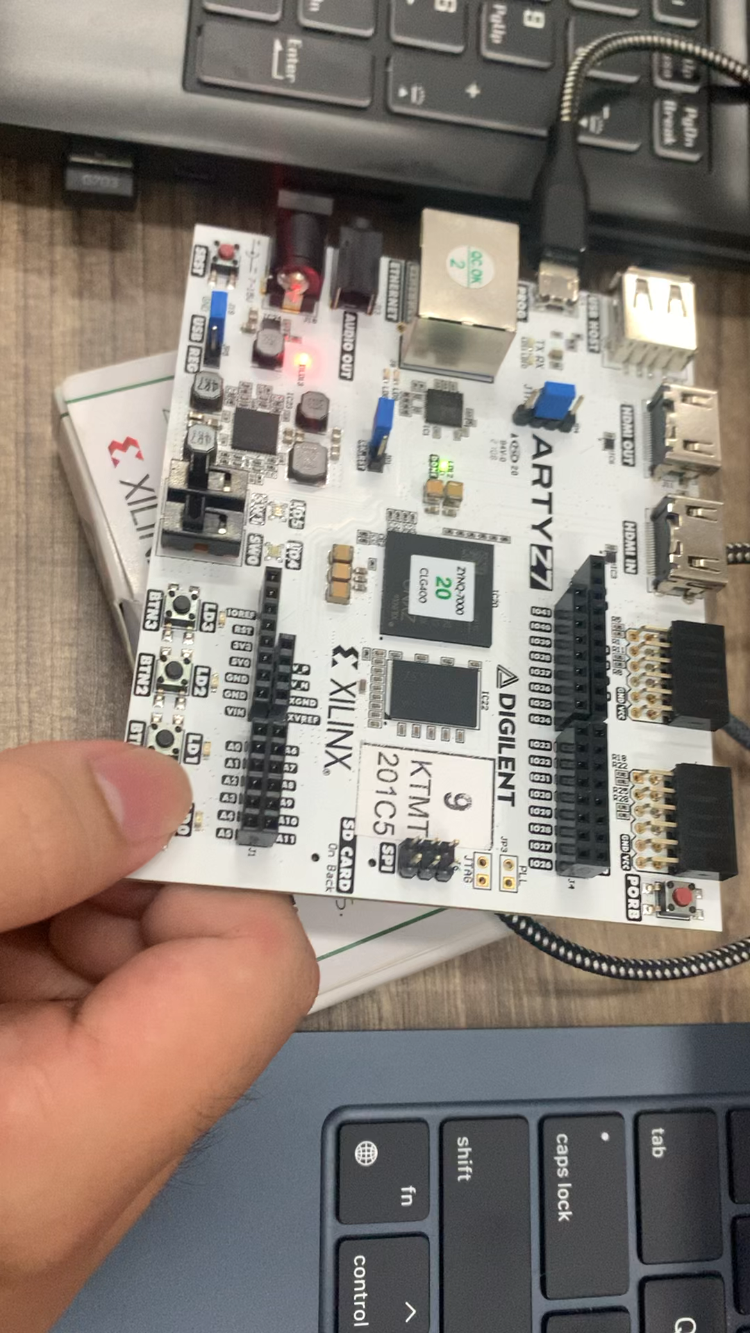

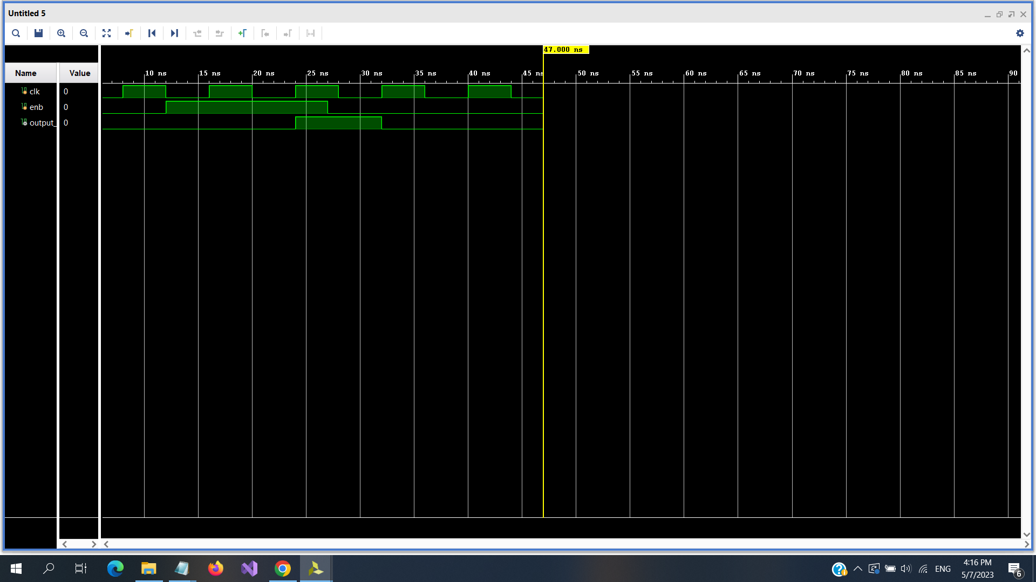

***b.******Write a 4-bit binary counter that counts up 1 unit when a button is pushed. Use the edge detection circuit to generate an enable signal for the counter when pushing the button. Test the design on FPGA board.***

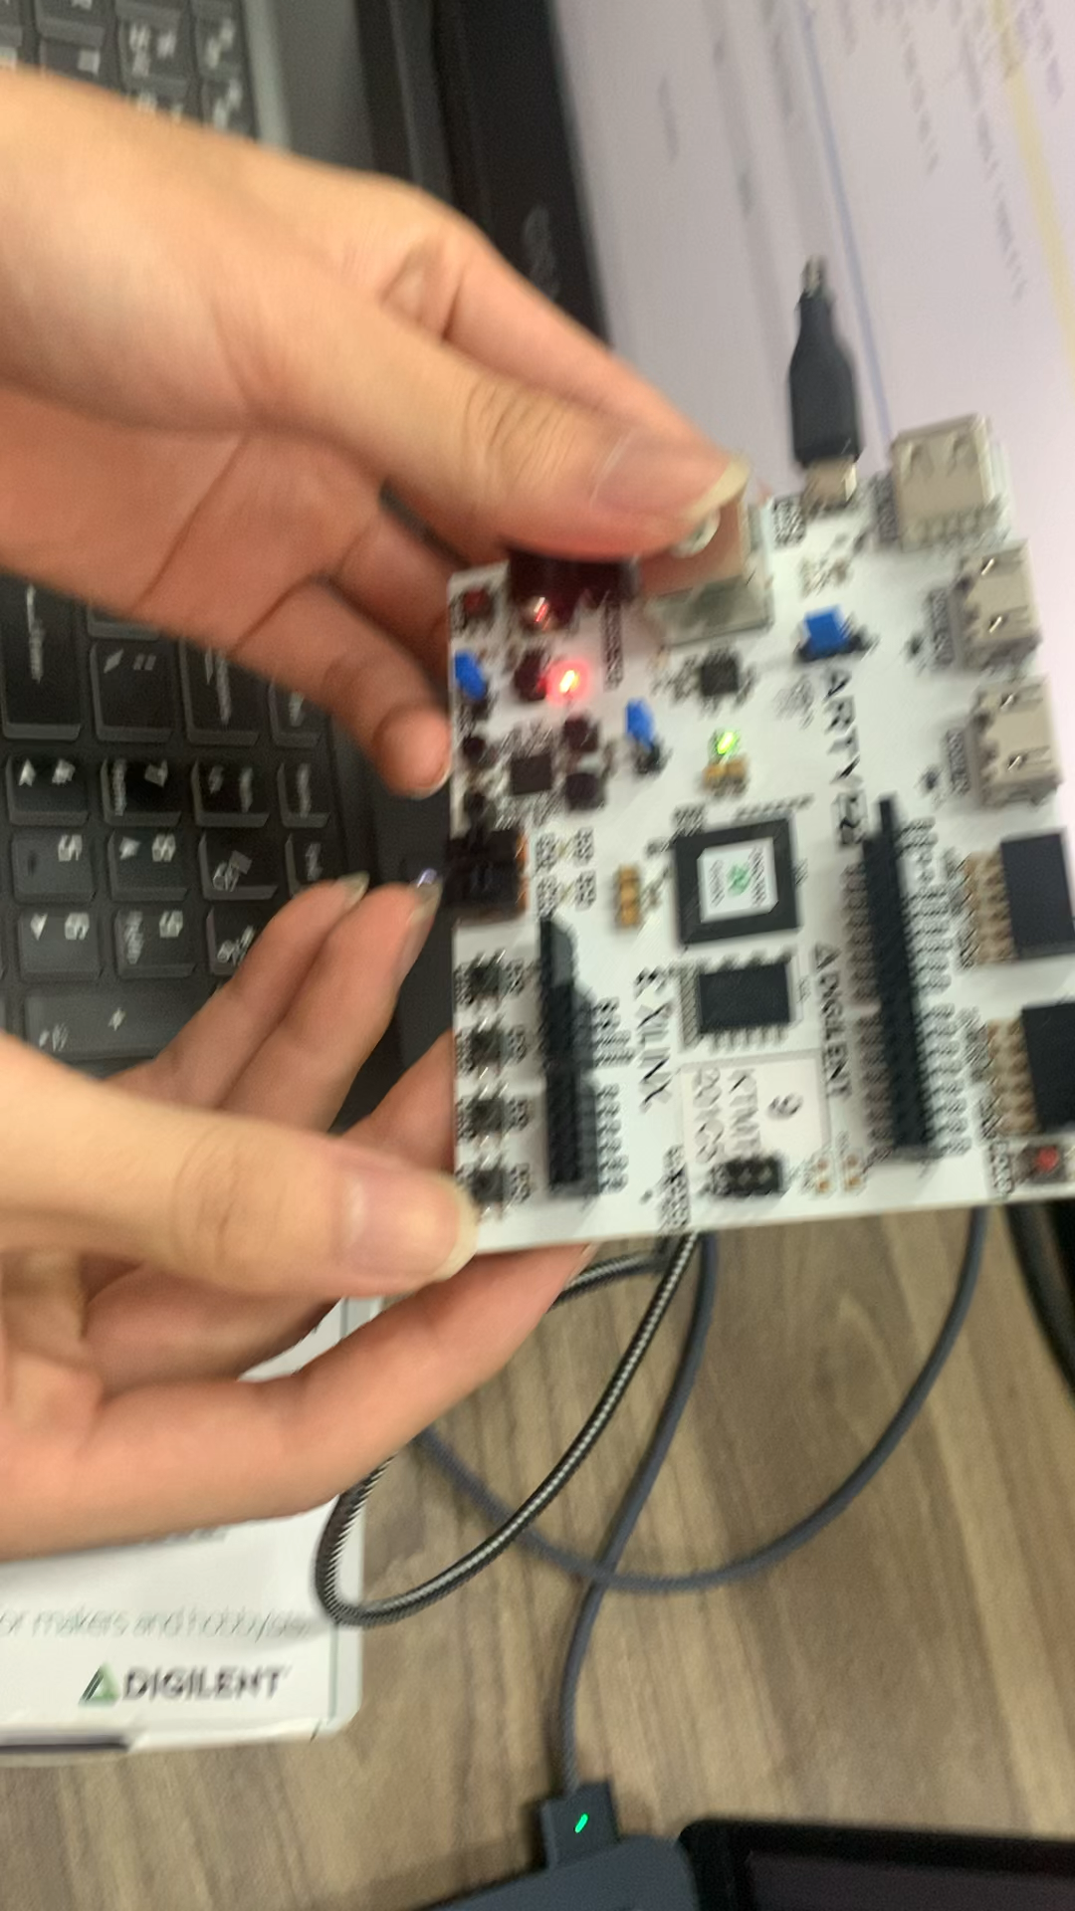

***2.3 Exercise 3***

***Change mode String bit LED circuit. Use Verilog HDL to model a state machine for a circuit that changes display mode of a bit string. In initial, LEDs show the default 4-bit random string which is performed by a reset signal, example string: 0011. And buttons in board will set the display mode as follow:***

***• Button 0: Mode Reset: Show the default 4-bit string on LEDs.***

***• Button 1: Mode Circular Shift Left Ring : Shift 4-bit string to left in a ring every 1s.***

***• Button 2: Mode Circular Shift Right Ring: Shift 4-bit string to right in a ring every 1s.***

***• Button 3: Pause: Pause the current shifting string.***

***Draw a state diagram to illustrate the designed FSM. Student can use Moore or Mealy model. Write a test bench to simulate the circuit and test the circuit on the Arty-Z7 board:***

`timescale 1ns / 1ps

module workspce(btn,clk,output_led);

input [1:0] btn;

input clk;

output reg [3:0] output_led;

reg [30:0] cnt;

always @(posedge clk) begin

if (btn == 0) begin

output_led = 4'b0011;

end

else if (btn ==1) begin

output_led <= {output_led[2:0],output_led[3]};

end

else if (btn ==2) begin

output_led <= {output_led[0],output_led[3:1]};

end

else if (btn ==4) output_led <= output_led;

end

endmodule

TEST BENCH:

`timescale 1ns / 1ps

module lab3_tb();

reg clk;

reg [1:0] btn;

wire [3:0] output_led;

initial begin

clk =1 ;

forever #5 clk = ~clk;

end

initial begin

btn = 2'b00;

#40

btn = 2'b01;

#40

btn = 2'b10;

#50

btn = 2'b11;

#40

btn = 2'b00;

#10 $stop;

end

workspce somthing(btn,clk,output_led);

endmodule

